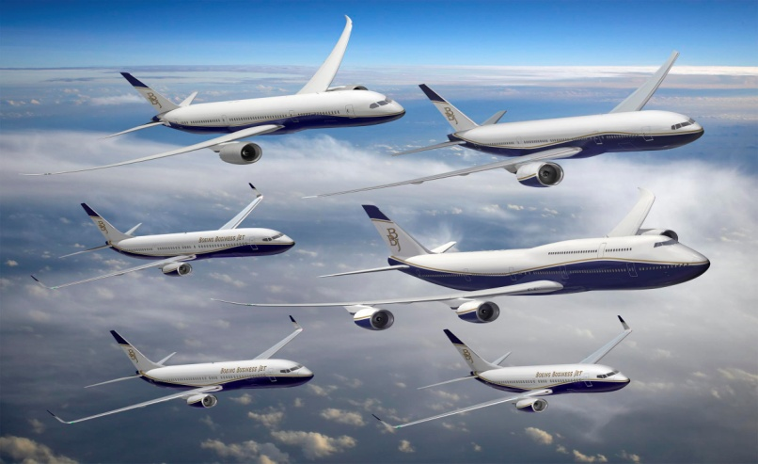**THE TRAGEDY OF FLIGHT-a COMPREHENSIVE CRASH ANALYSIS**

**J**

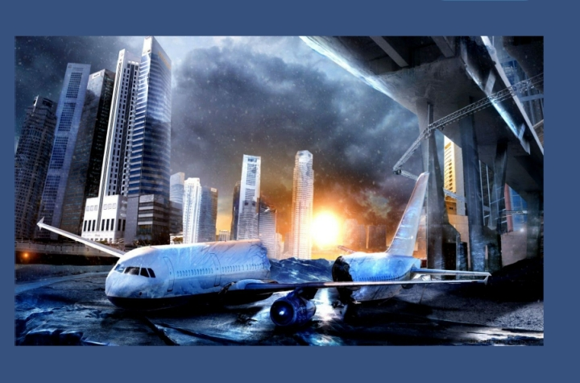

Team id:

Nm2023tmid05438

Team leader:

MAHIBHA.K

Team members:

* MINI.K
* FEMIBHA.D.G
* ARTHY.R.S

**PROJECT REPORT TEMPLATE**

***CONTENTS***

**INTRODUCTION**

* **Overview**

**A brief description about your project.**

* **Purpose**

**The use of this project. What can be achieved using this.**

**PROBLEM DEFINITION & DESIGN THINKING**

* **Emphathy Map**

**Paste the emphathy map screen shot.**

* Ideation and brain storming map

Paste the ideation and brain storming map sceenshot.

**RESULT**

* **Final findings(output)of the project along with screenshots.**

**ADVANTAGES AND DISADVANTAGES**

* **List of advantages and disadvantages of the proposed solution**

**APPLICATIONS**

* **The areas where this solution can be applied**

**CONCLUSION**

* **Conclusion summarizing the entire work and findings.**

**FUTURE SCOPE**

* **Enhancements that can be made in future.**

**APPENDIX**

* **Source code**

**Attach the code for the solution built.**

**INTRODUCTION**

**Overview**

* **ABOUT PROJECT**

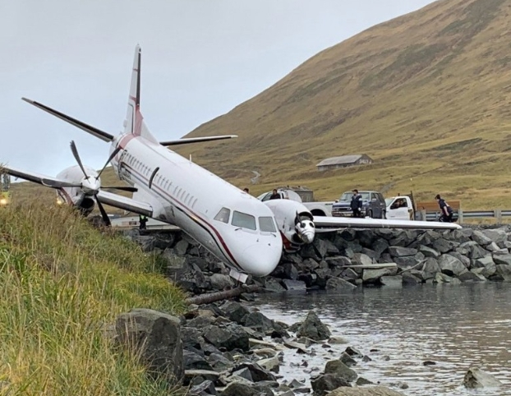

**This project is about the investigation about the causes for the flight accidents.The data are to be collected and linked with tableu and visualize .And it helps to prevent the future accidents.The data regarding the flight crashes happened on 1972 has been collected.**

* **PURPOSE**

**The main aim of this project is to prevent the future accidents that are caused by the aircraft. And the solutions can be given to avoid the fault again.The airplane travel is considered as the unsafe mode of transport among common people.**

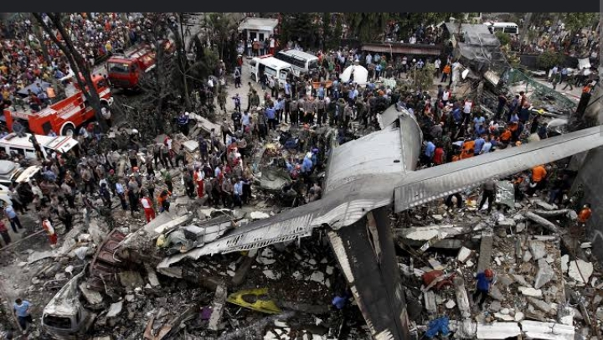

**This project also to prevent the fear of airplane travel and change the mode of travel as the safest in the minds of common people.**

**PROBLEM DEFINITION AND DESIGN THINKING**

* **EMPATHY MAP**

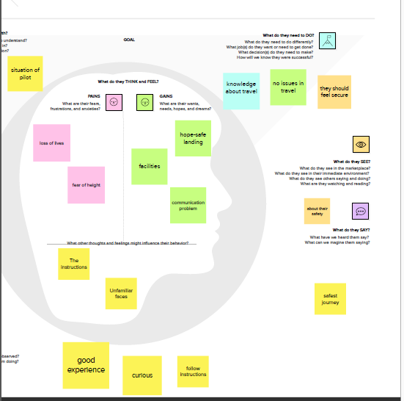

The empathy map defines the views of the team members. The factors that causes accident, fear of people, expectations of the people, mindset of the pilots etc,.

* **IDEATION AND BRAIN STORMING MAP**

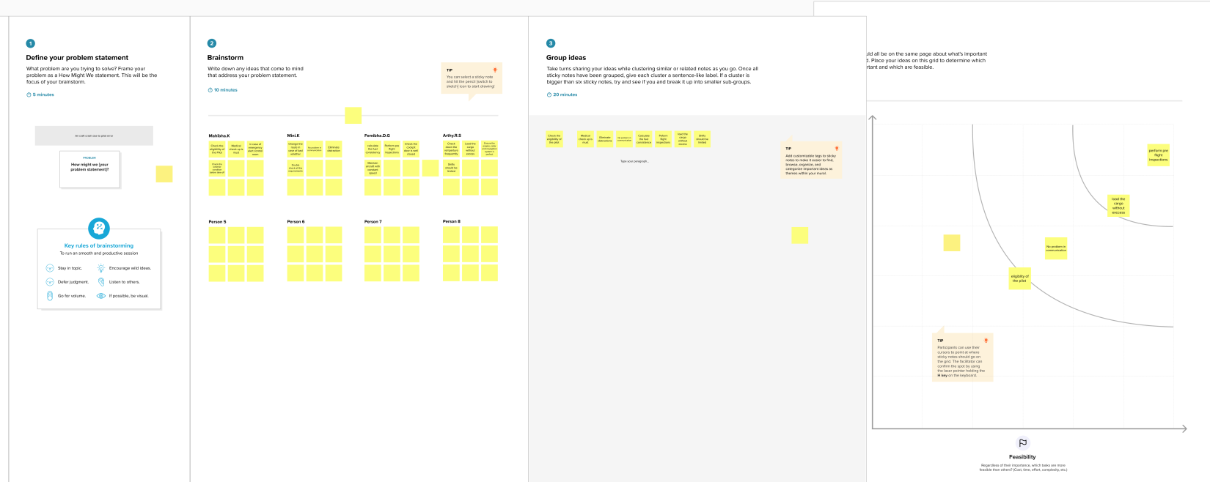

**Brainstorming is the ideas by the team members about the fight crash and the preventive measures that can be taken to prevent future accidents.**

**RESULT**

* **FINAL FINDINGS OF THE PROJECT (OUTPUT) ALONG WITH SCREENSHOTS**

**DASHBOARD**

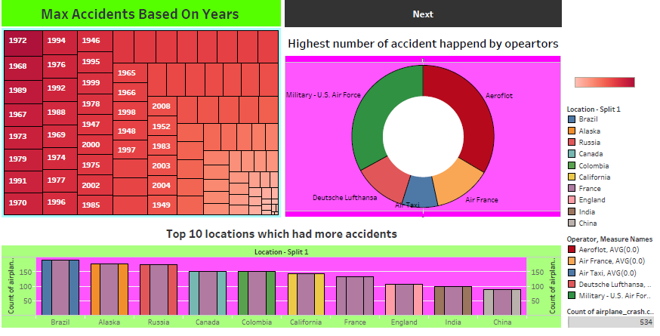

**The chart that visualizes the accident zone**

**and also the major accidents happened year and the**

**highest cause of accidents and top 10 locations which**

**had more accidents.**

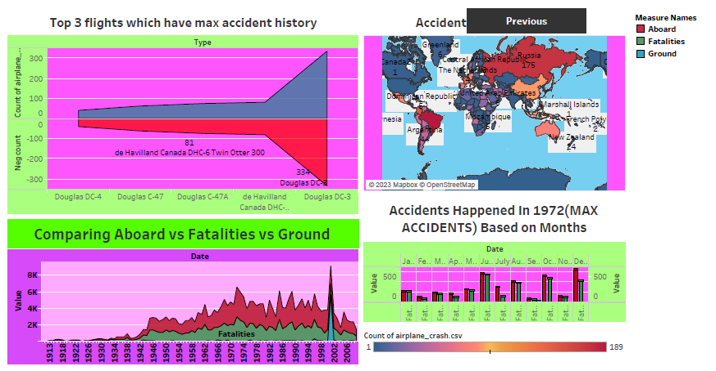

**The chart shows top three flights which have maximum accidents and comparing both the abroad and fatalities and the ground.And major accidents that are happened in 1972.**

**STORIES**

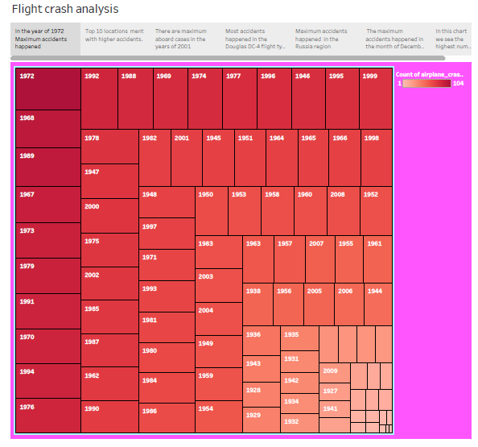

IN THE YEAR 1972 MAXIMUM ACCIDENTS HAPPENED

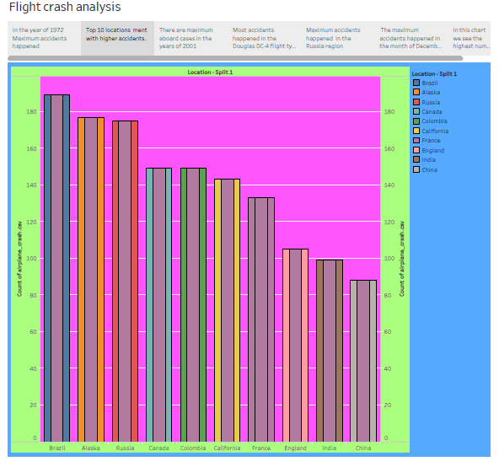

TOP 10 LOCATIONS WITH HIGHER ACCIDENTS

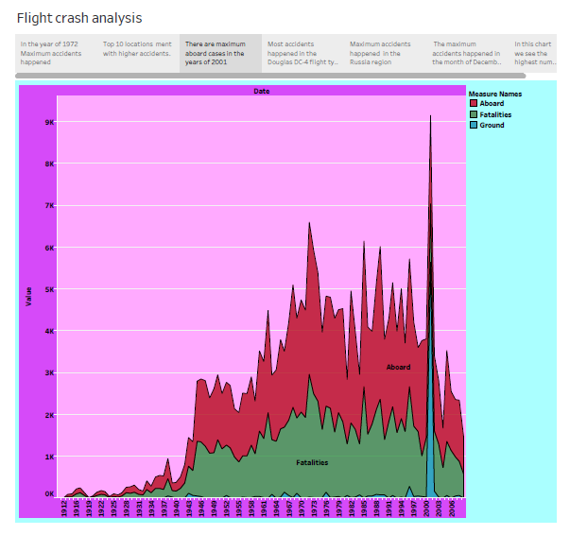

THERE ARE MAXIMUM ABROAD CASES IN THE YEAR OF 2001

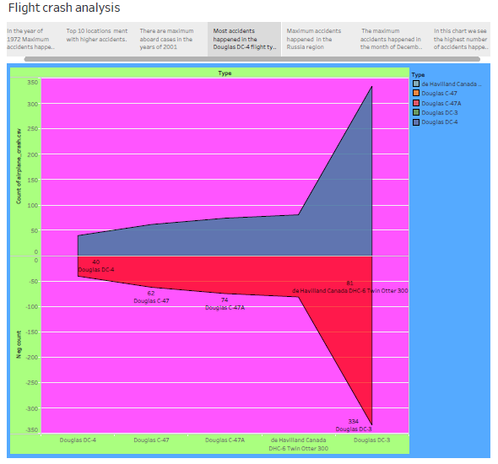

MOST ACCIDENTS HAPPENED ON DOUGLAS DC4 FLIGHT

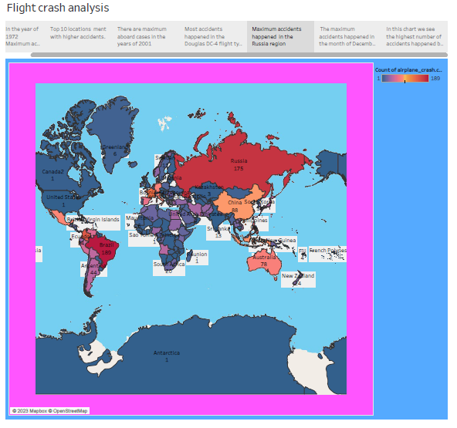

MAXIMUM ACCIDENTS ARE HAPPENED IN THE RUSSISA REGION

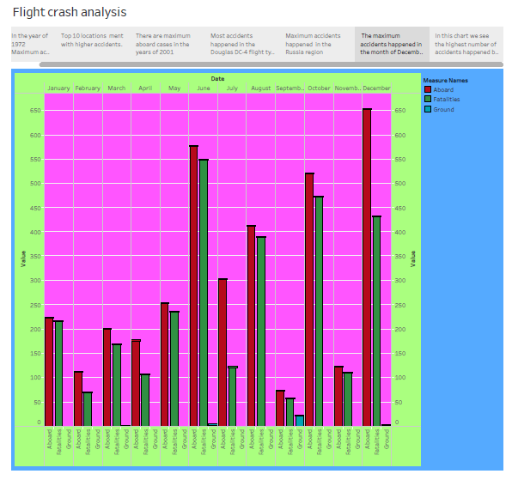

THE MAXIMUM ACCIDENTS ARE HAPPENED IN THE MONTH OF DECEMBER 1972

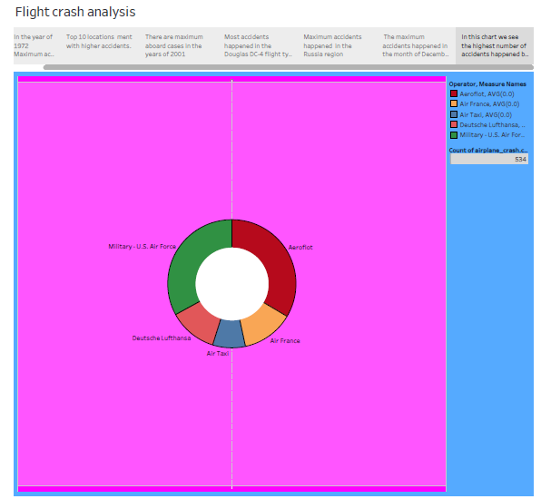

IN THIS CHART WE SEE THAT THE HIGHEST NUMBER OF ACCIDENTS HAPPENED IN AIRFORCE

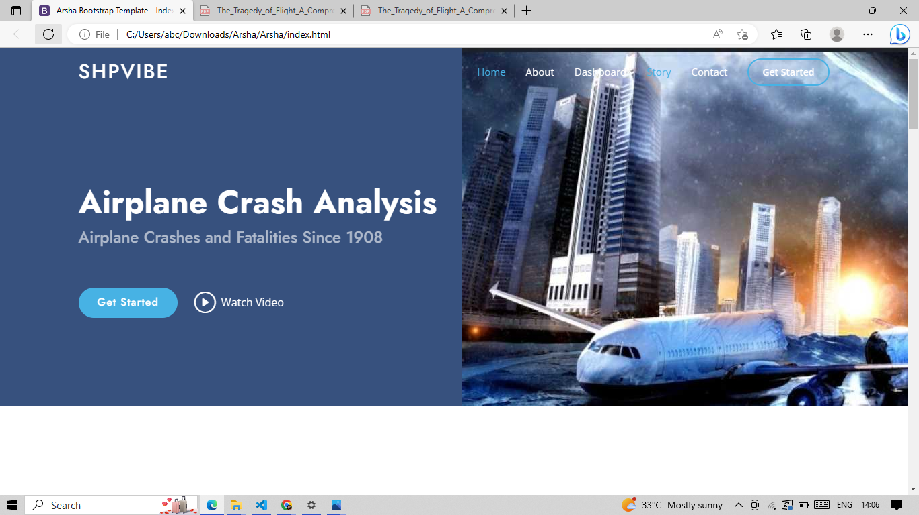

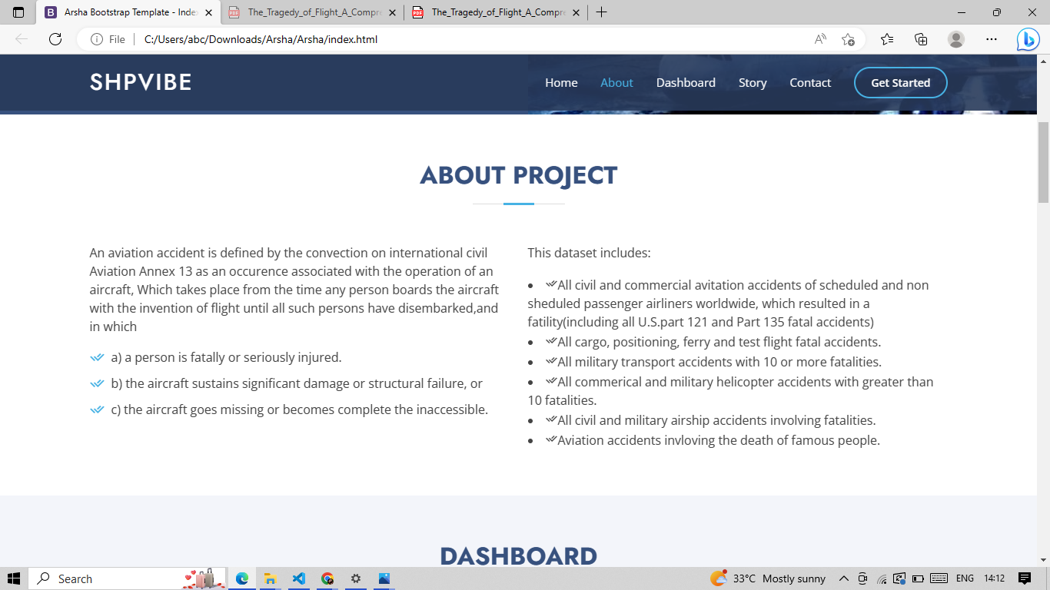

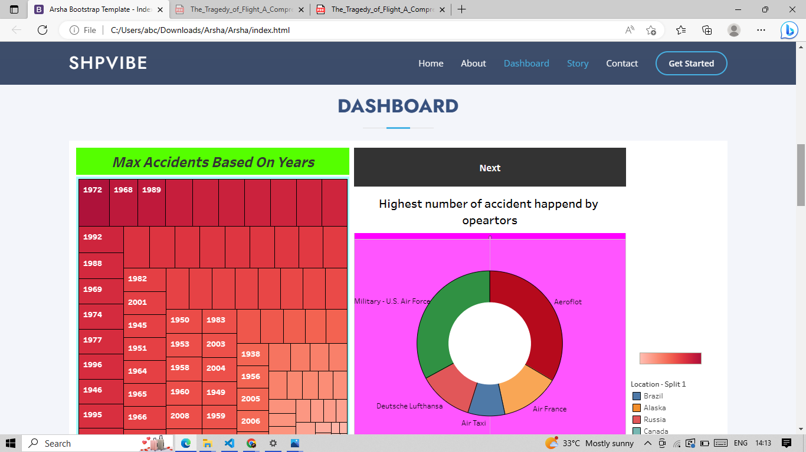

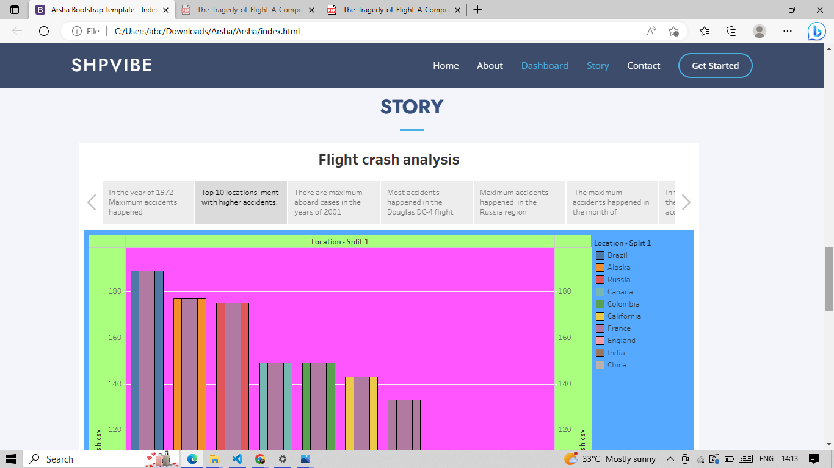

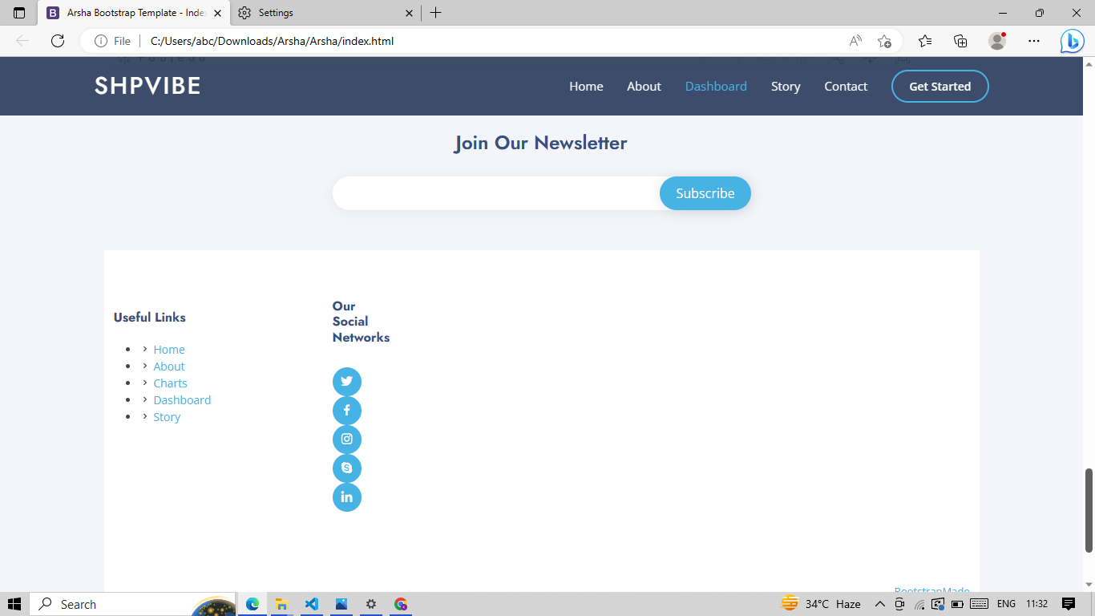

**ADVANTAGES AND DISADVANTAGES**

* **LIST OF ADVANTAGES AND DISADVANTAGES OF THE PROPOSED SOLUTION**

**ADAVANTAGES**

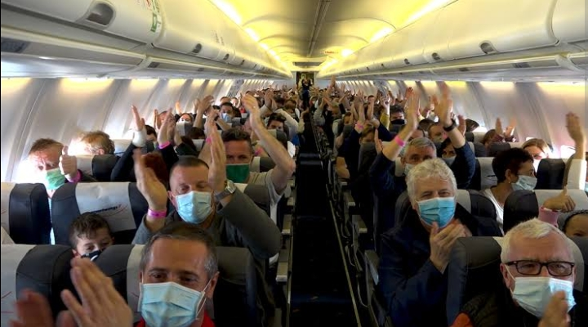

* **Improving safety of passengers during travelling.**
* **Taking preventive steps.**
* **Reducing the death rates.**
* **To know about the causes for accident.**
* **Can be sure that he plot is medically fit.**
* **Fear of communication can be reduced.**
* **Passengers should feel comfortable.**

**DISADVANTAGES**

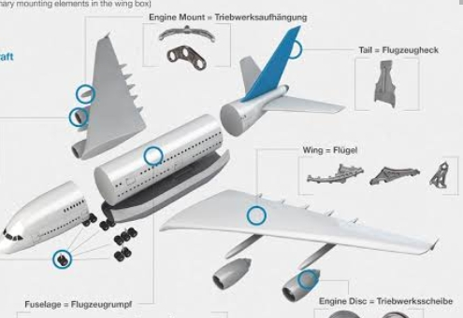

* **Unable to determine the accurate solutions.**
* **Requirement of costly spare parts.**
* **Need for more employees.**
* **Expenses may be high.**
* **Increase in the shifts.**
* **Limited passengers can be allowed**
* **Takes more time for proper check up.**

**APPLICATIONS**

* **THE AREAS WHERE THIS SOLUTION CAN BE APPLIED**

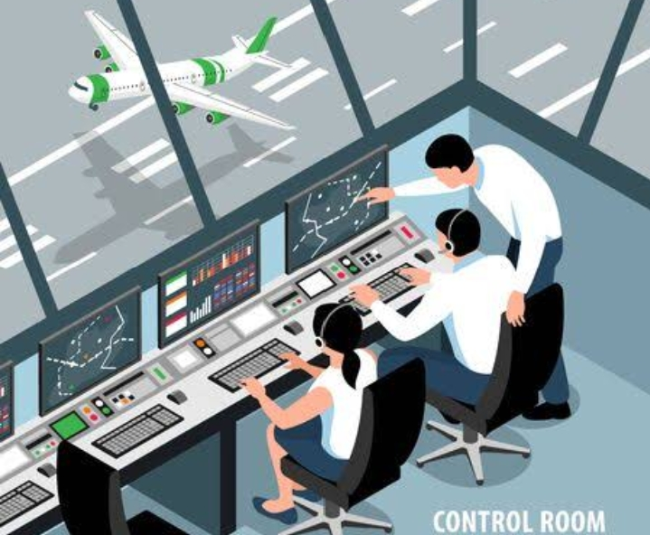

**This solution can be applied to the manufacturer and the person who check the condition of the spare parts and also the medical health of the pilot in order to prevent the pilot error, because major accidents are caused by the health issue of the pilot.And the communication problem between the control room and the pilot can also be rectified.**

**CONCLUSION**

* **CONCLUSION SUMMARIZING THE ENTIRE WORK AND FINDINGS**

**In this project we have collected the data given on the spreadsheet and connected it with the tabulo and created a clear visualization to find out the accident prone areas and the highest number of fatalities and the accidents that are caused due to the pilot and mechanical failures etc.**

**With the help of the visualization we can able to identify the errors and what can be done to prevent these errors and reduce the aircraft accidents.**

**And also created a template with the help of a**

**Template on bootstrap linked with the visual studio and created the code and opened to create a template.Thus the code is attached on the source code.**

**FUTURE SCOPE**

* **ENHANCEMENTS THAT CAN BE MADE IN FUTURE**
* **In future the technological fault may be prevented.**
* **Application of robotics can prevent mistakes.**
* **Flight travel can also be common as the bus travel.**
* **People will have no fear about the aircraft travel.**

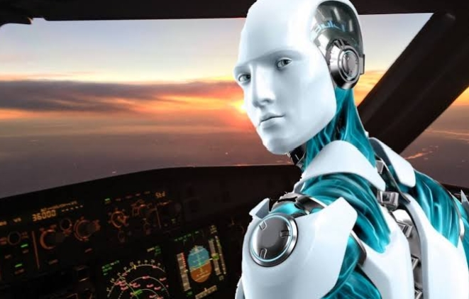

**APPENDIX**

* **SOURCE CODE**



